MPP111 Power Point Basics Exersizes

Title or Task: | MPP111 Power Point Basic Selection
Description: | Using the selection tools select various elements from the following files

Files Required
Suitable for Classes: | Y10 Multimedia, Small Business, Applied Information Technology
Area: | Technology & Enterprise
Teacher: | Mr Peter Faulks
Timeline | 1 lessons
Date Due: | In class
Task Brief: | This session requires some skill in using the mouse and computer
Development or Outcomes: | Ability to use Power Point

Items highlighted in yellow are tasks for you to complete


Items in Blue italics are help tips

These pages are designed to show you how to use software packages; various software updates may have taken place so some pages will not apply to versions other than those listed here. In some cases data files may be required.

WORKSHEET

Power Point Hyperlinks Worksheet

Return to Teacher

Hyperlinks handout Worksheet

- Open Power Point
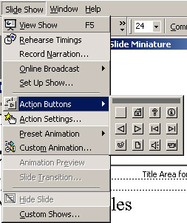
- Open your Slide Show
- Click on Slide 1 and select a text area
- Click on Slide Show Action Buttons and select <
- Draw this on your page and set the link to Previous Page use the selection arrow to show Previous Page
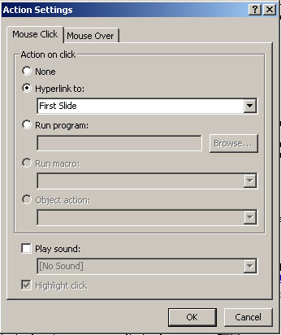

- Set up several buttons to show next page, last page, first page

- Copy this set of buttons to every slide

- Find the URL web address of a site you have visited for your product or presentation

- Click the hyperlink button

- Click the button Existing File or web page

and type in the URL address here
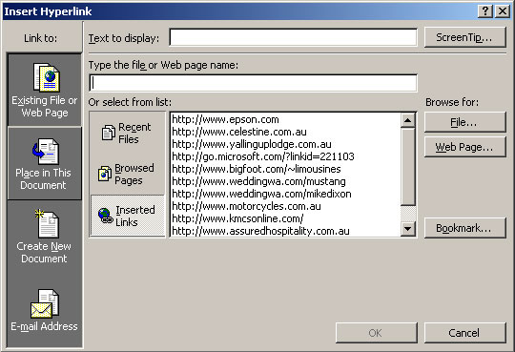

- Type Text to display i.e. Holden Car Link

Note: You can browse for a web page using the Browse for: buttons.

Create a Mailto: Email address so that clients can Email you

- Repeat above but click on E-mail Address Button and enter your E-mail address or
myname@school.com.au

Adding Sounds to hyperlinks

Click on add sound and add Chime to a mouse click or MouseOver action

- Play sound

Add more Buttons or try using hyperlinks on existing buttons (make your own - then link them)

